**Comp 3020: Project Milestone 2**

**Part (A): Group Brainstorming**

At the beginning of the brainstorming session, we discussed all the functional requirements that our project had, we evaluated each requirement and put them into pictures. Most of the pictures were based on the essential functional requirements, such as the page for movie showtimes, theater selection and transaction methods. Some of the other ideas that were drawn were food purchase selection, profiles for customers and prize draws. While pictures were being drawn, we would put our completed work in the middle of the table so others may have a point of reference when coming up with their own designs. Furthermore, having pictures in the middle of the table helped prevent duplicate ideas and made our process more efficient. During the session, some of us came up with ideas that weren’t initially discussed, and they were great additions to our project. At the end of the session, we chose the best three prototypes based on their creativity and design. These three prototypes will be refined further with additional details.

**Part (B): Idea Polishing**

**Group Payment Idea**

The main idea for this sketch is to make payment easy for both groups and individual purchases. Another feature in this design is the ability to pay without logging in. To pay without logging in, simply enter in your credit card details and receive your ticket through email. However, by logging in, we provide our users with the feature that will help in purchasing tickets as a group. Our system gives the user the ability to spread the payment of tickets between friends by allowing the user to add people into a payment pool. The percentage a user in the payment pool pays will be decided by the user that started the payment pool. Friends will receive payment invoice through email where they will have to login to their account and confirm their payment. This feature will also work for individual users since they can just decide not to add any friends into the payment pool and pay the whole bill.

The features discussed were decided with our requirements in mind. Users should be able to pay for tickets without logging in because most of our users are very casual movie watchers that watch less than one movie a month. Making it easy for the user to purchase tickets in a group is a very important feature that we would like to provide. By being able to spread payment for tickets through different users, this satisfies our environmental requirement of users potentially purchasing tickets in groups. With our system, only one person needs to go through the process of purchasing a ticket while the other users simply need to wait for an email to confirm their payment. These features help make our system more convenient for the users, saving them time and effort.

**User Account/Prize Draw**

The idea behind this sketch is to provide the user with a means of managing their account as well as providing incentive for the user to continue making purchases through a reward/point system. The idea provides the user with incentives by allowing them to spin a prize wheel using their points to potentially win a variety of different prizes. Users can acquire a chance to spin from collecting points received by purchasing movie tickets or concessions. This idea also provides the user with a simplistic means of managing their account by providing the user with only the necessary information. This allows for an elegant account interface without overwhelming the user with too much information.

This idea is appropriate given our requirements and user needs due to the simplistic account interface. This simplistic design meets our usability goal of creating a learnable system that the user will remember. This is done by limiting the information the user sees to a small subset of information that they will most frequently access. This idea also meets some of our functional requirements gathered in Milestone 1 such as, allowing the user to use their points card and see how many points they have on their card. In addition, we also meet the functional requirement of providing the user with an incentive to use the website by offering a prize draw system in the form of a wheel to spin to win various prizes.

**Home Page**

The idea for this sketch is the main navigation screen, which you will encounter when you first enter the web page. This provides the user with a navigation menu with a slide-show of large pictures showing movies that are currently playing or movies that are coming soon. In addition, users can click directly on the large images to continue with the process of purchasing a ticket for the movie or to see further information about a movie that is coming soon. The idea was to provide the user with a simple, highly visual first experience that is easy to understand. This idea was chosen as one with the most potential because it does not overload the user with too much information for them to process but also provides enough information for them to understand how to navigate the site.

This idea is appropriate in the sense that it meets a lot of our requirements from Milestone 1. It meets the requirement of being learnable because the interface is simplistic, allowing the users to easily learn how to navigate the web page with intuitive keywords describing each button. The top menu navigation was created using information gathered from the card sort method in Milestone 1 to mimic the user's mental model, adding to the learnability of the idea. This simplistic, yet visual design also adds to the memorability aspect we set as a requirement for our web page in Milestone 1. There is not an overload of information for the user to take in, making it easy for the user to remember how to navigate the web page. Learnability and memorability combine to meet one of our constraints we described in Milestone 1, being that most of our users will be novice, casual users. A learnable and memorable navigation screen cater directly to this audience, which will be approximately 64% of our users.

**Part (C): Hierarchical Task Graphs**

**Setting up an account**

**Choosing a movie experience**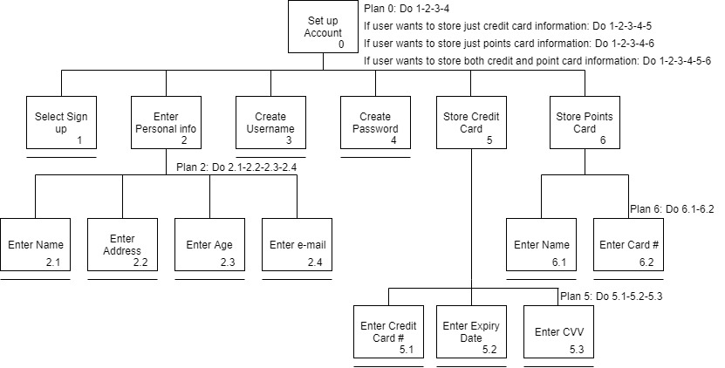

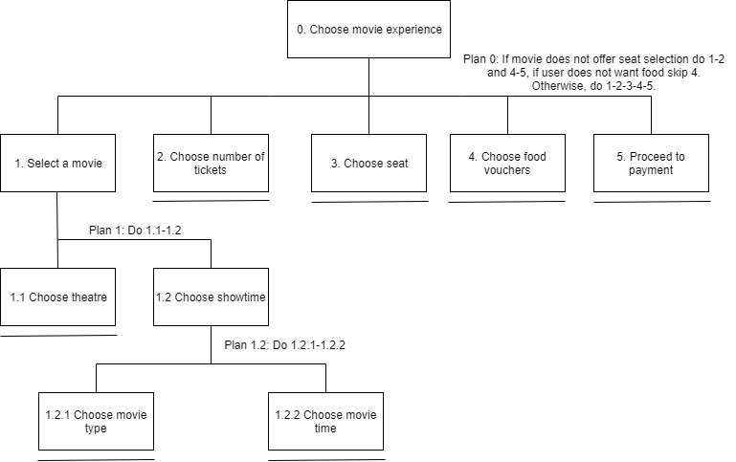

**Paying for a ticket**

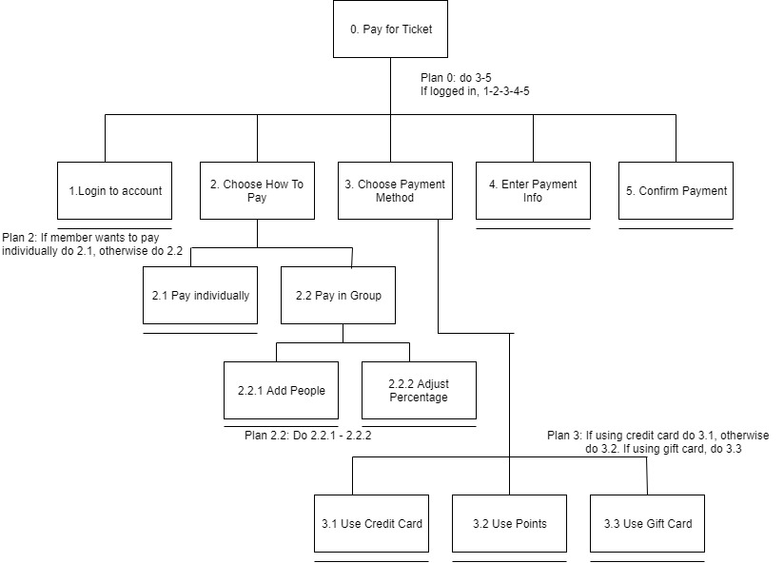

**Part (D): Low-Fidelity Prototypes**

**Note: All pieces of the paper prototype are labeled and referenced below.**

The purpose of our paper prototype is to showcase how to complete the three main tasks our system will support. The prototype will offer the ability to set up an account with our system, choose a movie you wish to see and to pay for a movie ticket. The prototype will allow the user to navigate through the various pages in a way similar to navigating through a website. The prototype allows for different screens to be displayed based on how the user interacts with the interface by placing different sheets of paper over one another to portray different screens and windows of the web page. The prototype should convey to the user the overall look and feel of the website, giving the user a sense of how intuitive the menu structure is. Our usability goals of learnability and memorability are conveyed through the prototype through our simplistic and easy to understand screens and menus. The prototype also conveys our functional requirements from Milestone 1, allowing the user to purchase a movie ticket, check the status of a movie (i.e. how many seats are left), show the user admission prices and display various showtimes for movies.

**Choosing a Movie Experience**

To choose a movie experience, you will begin at A1 and press showtimes. Then place page A5 below showtimes to simulate a drop down menu, where the user will then select their theatre of choice. Doing so, you will place C1 over A1 which will show the different movies and times they are playing. After selecting a time, put C2 on top of C1 to reach the screen where you select which tickets you wish to purchase. In this screen, to add a ticket, click the “+”, and to remove a ticket, click the “-” of the specific type of ticket. After deciding on your tickets, click next to reach seat selection. Replace C2 with C3 which is the seat selection screen. In the seat selection screen, once you have selected where you would like to sit, select next to confirm your seats. After hitting next, replace C3 with C4 to bring up the food and beverage menu. Here you can scroll through the different combos and press “-” and “+” to add combos that you would be interested in. After selecting your food and beverages, you will then proceed to pay for your movie ticket. The payment screen will replace C4 with D1A and will be discussed in the next topic.

**Payment**

To pay for a movie ticket, start with page D1A if the user is not currently logged into an account. If the user decides to log in to their account, flip D1A over to D1B and follow the instructions in the next paragraph. If the user chooses to purchase a movie ticket(s) without being logged in, enter the necessary credit card information and click “next”. Then replace page D1A with page D3 where the user will then select whether they would like an electronic form of their ticket or to print their ticket themselves.

If the user chooses to purchase a movie ticket(s) while logged into an account replace page C4 with D1B. The user will have the option to add friends to a payment pool if they choose to purchase the tickets in a group. If the “Add a friend to pool” button is pressed, place page D2 on the left half of page D1B. From this page the user can adjust the percentage of each person’s contribution to the payment pool. After the user selects their card to pay with, replace D1B with D3 where the user will then select whether they would like an electronic form of their ticket or to print their ticket themselves.

**User Sign-up**

When the user presses the Sign up button on the top right of the screen of page A1, page B1 will pop up in the centre of the webpage. After every field is filled out with acceptable inputs, press the next button on the bottom right of the page. Page B2 will replace B1 on the main screen of A1. After populating all the required fields and making sure that the input for password and confirm password matches, press next on the bottom right of the page to proceed to page B3. Page B3 will then replace B2 on the screen. You can press skip on the bottom of page B3 to go to page B4. You can also proceed to enter all your credit card information, the month and year inputs will be done by selecting the values from the drop down boxes. After all the fields are filled out correctly, press the next button on the bottom of page B3 to proceed to page B4. Once again, page B4 will replace page B3 on the screen. You can press the skip button to complete the sign-up process. You can also fill out the required information on this page and press the finish button on the bottom right of the page to complete the sign-up process. Following sign-up, place A2 over the sign-up/log in button on either A1 or C1 as the system logs the user in automatically.

**Part (E): Informal Prototype Evaluation**

After having 4 potential end users test our paper prototype, we found that most of the users who tested it thought the design was extremely straightforward and easy to understand. The users commented that navigating through the interface took them where they expected to be, in a logical manner. Most users also commented that they wanted to preview the seat selection screen before choosing how many tickets they wanted to get, so they would have a better idea if their seat(s) were available. Users mentioned that the seat selection screen should have labels for each row and seat, to allow them to find their seat at the theatre easier. Furthermore, showing the number of seats remaining for each movie was something that most of the users did find convenient. One user mentioned how it would be more intuitive for them if instead of just having the number of seats remaining, have a picture of a chair with the number of seats remaining inside the chair. A user mentioned that there should be a “No thanks” option when choosing food vouchers for the movie, because they did not want to purchase any food when they were using the prototype. Users said the information was well organized, and easy to read but the area of the sign up where it asks a user to connect their points card could be worded as “Card Number” rather than “Card Information”. Many of the users seemed to take a minute to try and interpret the group payment screen, most being confused when being abruptly taken to a method of payment that they are unfamiliar with. One user mentioned possibly adding some instructions on what the group payment process does to give it more context. All in all, every single user that used the prototype really liked the idea of paying as a group, mentioning that it would be a useful function because they rarely go a movie alone.